HOMEOSTASIS

THE NEED OF HOMEOSTASIS

Homeostasis is the maintenance of a constant internal environment.

It is the process of keeping the composition of the body fluids within narrow limits. By ensuring a relatively stable internal environment, homeostasis provides the organism with a certain degree of independence from variations in external environmental conditions.

External environment is the environment in which organisms live. Whereas, internal environment is the one in which the cells of the organism live — in mammals this is the tissue fluid.

Cells in bodies of animals are efficient but demanding. They have to be kept at the right temperature, and must be bathed in tissue of the correct pH and the right water potential. This means that these animals which include humans have to keep the composition of tissue fluid within very narrow limits.

NEGATIVE FEEDBACK

Negative feedback is the mechanism by which the body maintains conditions within particular limits. The body will do this by opposing a change that deviates from the normal. The diagram below helps to explain this using the example of body temperature.

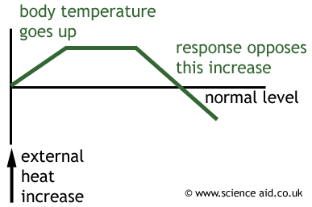

For any homeostatic control to occur there must be:

- A stimulus which is a change in the internal environment.
- A receptor which can detect the stimulus.
- An automatic or self regulatory corrective mechanism, which brings about
- A negative feedback.

Normal condition(norm)
Normal condition(norm)

Corrective mechanism
Corrective mechanism

Negative feedback
Stimulus (below normal)
Negative feedback

Stimulus (above normal)

* A schematic diagram to illustrate the principle of homeostasis.

EXAMPLES OF HOMEOSTASIS IN MAN

- REGULATION OF BLOOD GLUCOSE CONCENTRATION:

Glucose is the transport carbohydrate in animals, and its concentration in the blood affects every cell in the body. Its concentration is therefore strictly controlled within the range 0.8 – 1g per dm3of blood, and very low levels (hypoglycaemia) or very high levels (hyperglycaemia) are both serious and can lead to death. Blood glucose concentration is controlled by the pancreas. The pancreas has glucose receptor cells which monitor the concentration of glucose in the blood, and it also has endocrine cells(called the Islets of Langerhans), which secrete hormones. The α-cells secrete the hormone glucagon, while the β-cells secrete the hormone insulin. These two hormones are antagonistic, and have opposite effects on blood glucose:

• insulin stimulates the uptake of glucose by cells for respiration, and in the liver it
stimulates the conversion of glucose to glycogen (glycogenesis). It therefore decreases
blood glucose.

• glucagon stimulates the breakdown of glycogen to glucose in the liver (glycogenolysis), and in extreme cases it can also stimulate the synthesis of glucose from pyruvate. It therefore increases blood glucose.

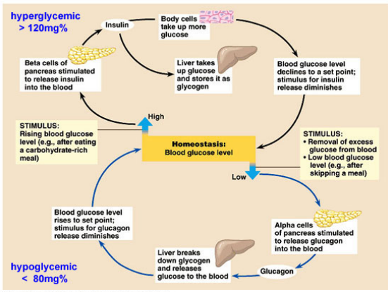

After a meal, glucose is absorbed from the gut into the hepatic portal vein, increasing the blood glucose concentration. This is detected by the pancreas, which secretes insulin from its β-cells in response. Insulin causes glucose to be taken up by the liver and converted to glycogen. This reduces blood glucose, which causes the pancreas to stop secreting insulin.

If the glucose level falls too far, the pancreas detects this and releases glucagon from its α-cells. Glucagon causes the liver to break down some of its glycogen store to glucose, which diffuses into the blood. This increases blood glucose, which causes the pancreas to stop producing glucagon.

Because blood glucose levels are allowed to deviate from the set point by about 20% before any corrective mechanism is activated, glucagon and insulin can never both be produced at the same time.

- REGULATION OF BLOOD WATER POTENTIAL:

We have seen in the “excretion” chapter, how our kidneys help to regulate the water potential (osmotic pressure) in the blood.

- TEMPERATURE REGULATION:

Another important example of homeostasis is the regulation of body temperature. To understand this, we need to know something about the structures and functions of animal skin.

THE STRUCTURE OF MAMMALIAN SKIN

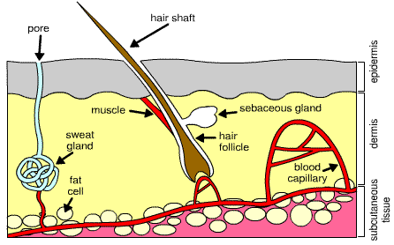

The diagram above shows a vertical section shows that it is composed of two main parts— an outer part called the epidermis, and an inner, thicker part, the dermis.

- EPIDERMIS:

This is a complicated epithelium consisting of:

- The outer cornified layer
The cells in this layer are dead, dry, flat and horny because of the deposition of keratin which is a protein. This layer is water-resistant and prevents uncontrolled water loss by evaporation. It also prevents germs from taking entry into the body unless there is a cut. The cells of this layer continually rub off and are replaced by cells from underneath. This layer is the thickest on the places which are subject to greater wear and teat e.g. souls of feet.

- The granular layer:
This layer consists of living cells, which, as they move upwards, become dry and horny, giving rise to the cornified layer.

- The inner most Malpighian layer:
This layer contains pigmented living cells. This pigment is called ‘melanin’ and it gives the skin its characteristic color. It also protects against the ultraviolet rays of the sun. These cells also finally become a part of the outer cornified layer as new cells take their places which are formed by the process of cell division.

- DERMIS

The dermis consists mainly of fibrous connective tissue. Its upper part is thrown into ridges or papillae. The following structures can be found embedded in the dermis (refer to the diagram above).

- Fat Cells: the layer of fat under our skin acts as an energy store - but it is also an insulating layer. In animals that live in cold conditions (such as whales and sea-lions) the layer of fat cells is quite thick which slows down the heat lost from the body to the outside.
- Blood Capillary: all living cells need to be near a fresh blood supply - to get food and remove waste. However, The blood is a good way for the body to lose heat. In hot conditions people can appear flushed - this is due to an increased blood supply to the skin in order to lose body heat. However, in the cold, the blood supply is restricted so some people may appear more pale.
- Muscle: Each hair has a small muscle attached to it. When conditions are cold the muscle will contract and this raises the hair. In hairy animals, this causes a layer of warmer air to be trapped near the skin - protecting it from the colder air a little further away.
- Sweat Gland: This structure makes sweat. Sweat is used to cool the body as it evaporates from the warm skin surface. It also has a specific scent.
- Sebaceous Gland: This produces an oily substance called sebum which coats the hair. It can also give the hair water-resistant properties. This would keep rain from reaching the skin surface and cooling it down.

HEAT PRODUCTION AND HEAT LOSS

Heat is produced within the body due to the various metabolic activities taking place. The blood helps to distribute heat produced to various parts of the body. However, extra heat can be gained by eating hot food or high temperature of weather. This extra heat has to be lost or we may die of overheating. This heat is lost by:

- Through the skin by convection, conduction and radiation (only by a limited extent).
- By evaporation of sweat from the surface of the skin.
- In the faeces and urine.
- In the expired air exhaled by lungs.

Fishes, amphibians, reptiles and invertebrates cannot regulate their body temperature and therefore their body temperature is not constant. These animal are therefore known as poikilothermic animals.

Whereas, mammals and birds can maintain their internal body temperature and are therefore known as homoeothermic animals.

ADVANTAGES OF A CONSTANT BODY TEMPERATURE

- Homoeothermic animals can remain active throughout the year irrespective of the environmental conditions.
- Enzymes work best at the constant optimum temperature of the body.
- Animals can feed throughout the year without the need of hibernating.
- Animals can colonize and exploit areas with different climatic conditions.

THE REGULATION OF BODY TEMPERATURE

The hypothalamus of the brain monitors the temperature of the blood that passes through it. The hypothalamus also receives information about the external temperature from temperature receptors in the skin.

The table shows that what goes in the body when the temperature either falls below the normal or ruses above the normal.
